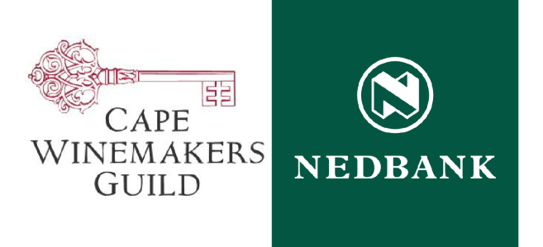

2013 NEDBANK CAPE WINEMAKERS GUILD AUCTION – LIST OF WINES ON OFFER

WINE NAME QUANTITY ON OFFER

AA Badenhorst Family Wines Grenache Gris Vuilgoed 3 2012 40 x 6 x 750ml
AA Badenhorst Family Wines Siebritskloof Shiraz L.D.R. 2011 60 x 6 x 750ml
Ataraxia Under The Gavel Chardonnay 2012 40 x 6 x 750ml
Beyerskloof Traildust Pinotage 2011 40 x 6 x 750ml
Boekenhoutskloof Syrah Auction Reserve 2011 30 x 6 x 750ml
Boplaas Cape Vintage Auction Reserve 2009 30 x 6 x 750ml
Boplaas Ox Wagon 1880 Auction Reserve Potstill Brandy 24 x 6 x 750ml
Boschkloof Auction Reserve Syrah 2011 40 x 6 x 750ml
Bouchard Finlayson Auction Reserve Domaine Chardonnay 2012 80 x 6 x 750ml
Bruce Jack Happy Hour 2009 60 x 6 x 750ml
Cape Point Vineyards Auction Reserve White 2012 44 x 6 x 750ml
Cederberg Teen Die Hoog Shiraz 2011 60 x 6 x 750ml
De Grendel Op Die Berg Pinot Noir 2011 44 x 6 x 750ml
De Grendel Wooded Sauvignon Blanc 2013 44 x 6 x 750ml
Edgebaston Cabernet Sauvignon Reserve 2011 50 x 6 x 750ml
Ernie Els CWG 2011 70 x 6 x 750ml
Etienne le Riche Auction Reserve Cabernet Sauvignon 2010 80 x 6 x 750ml
Graham Beck Wines Non Plus Ultra Cap Classique 2008 40 x 6 x 750ml
Graham Beck Wines The Catalyst 2010 50 x 6 x 750ml
Grangehurst Auction Reserve 2007 70 x 6 x 750ml
Groot Constantia Auction Reserve Shiraz 2010 40 x 6 x 750ml
Hartenberg Auction Reserve Cabernet Sauvignon 2010 80 x 6 x 750ml
Hartenberg Auction Reserve Shiraz 2010 80 x 6 x 750ml
Haskell Vineyards Merlot 2010 70 x 6 x 750ml
Haskell Vineyards Paradigm 2008 70 x 6 x 750ml
Hermanuspietersfontein Vloekskoot Sauvignon Blanc 2012 70 x 6 x 750ml
John Loubser Thirteen 2011 42 x 6 x 750ml
Jordan Chardonnay Auction Reserve 2012 80 x 6 x 750ml
Jordan Sophia 2010 80 x 6 x 750ml
Kaapzicht Cape Blend 2010 60 x 6 x 750ml
Kanonkop CWG Paul Sauer 2010 60 x 6 x 750ml
Kleine Zalze 3 Expressions 2010 80 x 6 x 750ml
Lanner Hill Double Barrel White 2012 60 x 6 x 750ml
Luddite "Just Alice" Shiraz Mourvèdre 2010 100 x 6 x 750ml
Miles Mossop Wines Maximilian 2011 60 x 6 x 750ml
Neil Ellis Auction Reserve 2011 60 x 6 x 750ml
Neil Ellis Auction Reserve Pinotage 2011 40 x 6 x 750ml
Nitida Sauvignon Blanc Barrel Twenty Eight 2013 40 x 6 x 750ml
Paul Cluver CWG Pinot Noir 2011 40 x 6 x 750ml
Paul Cluver Wagon Trail Chardonnay 2012 40 x 6 x 750ml
Rijk's CWG Chenin Blanc 2012 44 x 6 x 750ml
Rijk's CWG Shiraz 2011 38 x 6 x 750ml
Rust en Vrede CWG Estate 2010 40 x 6 x 750ml
Saronsberg CWG Viognier 2011 26 x 6 x 750ml
Saronsberg Die Erf Shiraz 2011 42 x 6 x 750ml
Sijnn Syrah 2011 (1.5 Litre bottles) 12 x 3 x 1.5L
Sijnn Syrah 2011 (750ml bottles) 66 x 6 x 750ml
Simonsig "The Russety One" Roussanne 2012 32 x 6 x 750ml
Simonsig Heirloom Shiraz 2011 70 x 6 x 750ml
Spier Auction Reserve Frans K Smit 2010 72 x 6 x 750ml
Teddy Hall Eva (Krotoa) Chenin Blanc Noble Late Harvest 2012 40 x 6 x 375ml
Teddy Hall Maria van Swaanswijk Chardonnay Auction Reserve 2012 60 x 6 x 750ml
The Drift We're Here 2011 60 x 6 x 750ml
Tokara Tribute 2012 60 x 6 x 750ml
Villiera Meteor Cap Classique 2008 40 x 6 x 750ml
Vriesenhof Cabernet Sauvignon 2007 100 x 3 x 1.5L
Vriesenhof Pinot Noir Bin 115 2008 74 x 6 x 750ml
Waterford Estate 2009 Auction Reserve 2BB 50 x 6 x 750ml
Waterford Estate Chardonnay Auction Reserve 2011 30 x 6 x 750ml

The 2013 Nedbank Cape Winemakers Guild Auction is open to the public and will take place on
Saturday 5 October 2013
at Spier Conference Centre, Stellenbosch

For further enquiries, to bid on the auction, or to attend a pre-Auction tasting, please contact
Kate Jonker at the Cape Winemakers Guild Office on +27 (0)21 852 0408 or info@capewinemakersguild.com

Telephonic, online and proxy bidding options are also available for those unable to attend.

