19 August 2020

To Whom It May Concern,

ALCOHOL SAMPLES REQUIRED FOR INTERNAL ASSESSMENT ONLY: NOT FOR SALE OR DISPENSING

This letter serves to confirm the contents (2 x 750ml wine bottles per entry) in transit on 20 July 2020 are being delivered to:
Winemag (Pty) Ltd
Attention: Christian Eedes
44 Liesbeek Road
Rosebank
Cape Town
0834543644

The sample wine will be used only for judging purposes and is not for sale or dispensing. The results of the adjudication process will feature on the Winemag.co.za website in due course.

Yours sincerely

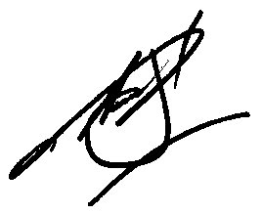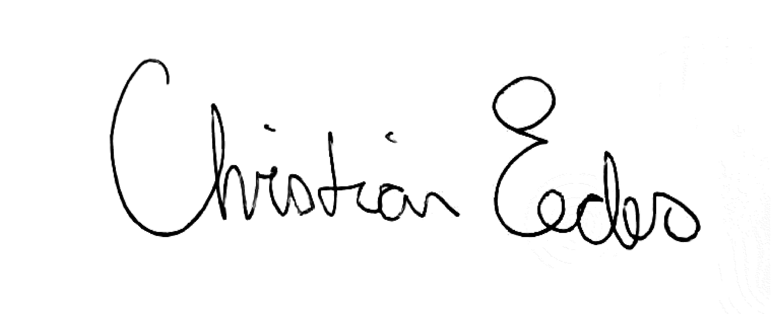

Jacqueline Lahoud Christian Eedes
Business Director Editorial Director
+27 83 654 7721 +27 83 454 3644
jax@winemag.co.za christian@winemag.co.za

